5.4 Green’s Theorem

In many ways Green’s Theorem is the Climax of MTH 202 because it unites the concepts of partial differentiation, double integrals, and line integrals. In order to fully understand the statement of Green’s Theorem we must go over one more concept.

Definition: The positive orientation of a simple closed curve C refers to a single counterclockwise transversal of C. So, if C is given by the vector function where and D is the plane region that is bounded by C, then the region D is always on the left as the point traverses C.

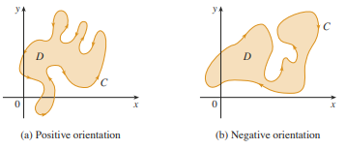

Example 1: Give a parameterization of the unit circle so that the curve given by your parameterization has positive orientation.

One possible answer is where . This answer can easily be seen to be correct if one graphs it on a calculator or if one plots a few points on this curve by hand.

Theorem (Green’s Theorem): Let C be a positively oriented, piecewise-smooth, simple closed curve in the plane and let D be the region bounded by C. If P and Q have continuous partial derivatives on an open region that contains D, then .

Notation: The notation is sometimes used to indicate that the line integral is calculated using the positive orientation of the closed curve C.

Notation: Another notation for the positively oriented boundary curve of D is . So, one could write: .

Example 2: Evaluate where C is the triangular curve consisting of the line segments from (0,0) to (1,0), from (1,0) to (0,1), and from (0,1) to (0,0).

A picture of the curve C and the region, D, that it encloses shown below.
We wish to apply Green’s theorem to find the desired line integral. Using the notation of the theorem we have that and .
We note that C is a positively oriented, piecewise-smooth, simple closed curve in the plane.
We also note that P and Q have continuous first order partial derivatives in which certainly contains D.
So, by Green’s theorem: .

We note that .
So, the answer is .
Note: One should think about the difficulties of doing the above example if Green’s Theorem is not available.

While the above shows how Green’s Theorem would work, we have yet to provide any sort of justification that this idea is actually valid. Now we provide a partial proof of Green’s Theorem.
Theorem (Green’s Theorem): Let C be a positively oriented, piecewise-smooth, simple closed curve in the plane and let D be the region bounded by C. If P and Q have continuous partial derivatives on an open region that contains D, then .

Green’s Theorem is quite difficult to prove in general, but we will give a proof for the special case where the region D is both type 1 and type 2. We will refer to such regions as simple regions.

Partial Proof of Green’s Theorem When D is both Type 1 and Type 2:

We first notice that if we can show that and we will have proven the desired.
Since D is a type 1 region we know that we can express D as where and are continuous on .

A possible picture of D is below:
The curves and may reduce to a single point.

Now, we note that .

We note that the x coordinate is constant for both the curves and . In particular in the curve we have , and in the curve we have , Thus, we have that .
Now, a parameterization for is where . This means . Also a parameterization for is where . This means that .
If we combine all the facts we have thus far we see that:

A very similar argument to the one above (Note: I would encourage you to try to come up with it) can be used to show .
Note: To prove Green’s Theorem in general one must prove that the region D can always be decomposed into simple regions.
Example 3: Evaluate where C is the circle of radius 2 centered at (1,5).

We immediately notice that C is a smooth, simple closed curve in 2 space. Moreover, and have continuous partial derivatives in two space which certainly contains the region D that C encloses.
So, by Green’s Theorem we have .

Notice, we did not even have to find an iterated integral since we know the formula for the area of a circle.

Example 4: Suppose that C is a positively oriented, piecewise-smooth, simple closed curve in the plane and suppose D is the region bounded by C. TRUE or FALSE: yields the area of D.

This is TRUE. To see why note that by Green’s Theorem .

A Generalization of Green’s Theorem:
Green’s Theorem can be generalized to apply to regions with holes, that is, regions which are not simply connected. Consider the following situation:
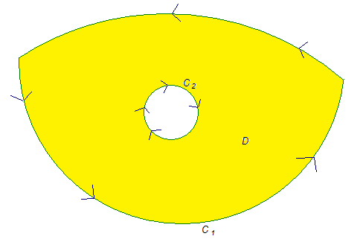
We let C be the curve that is made up of the union of both and . We assume that both and are positively oriented, piecewise-smooth, simple closed curves. Clearly the region D bounded by C has a hole in it.
Suppose we want to find where P and Q have continuous first order partials on a region containing D. To do this we divide up the region D as follows.
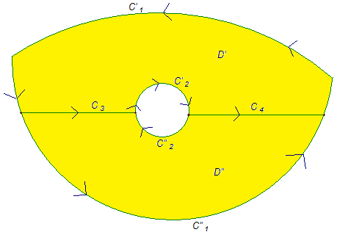

Let be the curve made up of , , , and . Similarly, let be the curve made up of , , , and . We note that both and are positively oriented, piecewise smooth, simple closed curves. So, by the basic version of Green’s Theorem we know that:
and . If we add these equations we obtain:

Thus, we have that .
So, Green’s Theorem still holds for regions with holes.

Example 5: Suppose that is the unit circle with counterclockwise orientation. Suppose that is the circle centered at the origin with radius 2 and with counterclockwise orientation. Let C be the positively oriented curve given by .

- Sketch a picture of C and the region that it encloses.

A picture is:
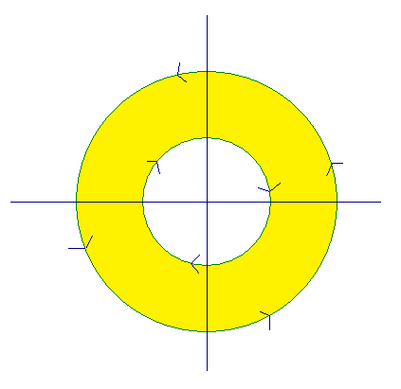
The region, D, that C encloses is shaded in yellow.

- If , calculate .

We note that the components of F have continuous first order partials everywhere in except the origin. Since the region that C encloses does not include the origin we know that the generalization of Green’s Theorem applies. So, we have that

